Collocation Dictionary

What is Collocation Dictionary
# Source: AI Source: Provided by: [Data Path: Persons Table -> ID Column: 1, Name_En Column: Motasem Essam] -> From: [Chatgpt (GPT-4-turbo)] on [7/29/2025]
A Collocation Dictionary is a specialized dictionary that focuses on word combinations—that is, which words naturally go together in a language. These dictionaries help users understand how to use words correctly and fluently by showing common, natural word pairings (collocations).

🔹 Key Features of a Collocation Dictionary
# Source: AI Source: Provided by: [Data Path: Persons Table -> ID Column: 1, Name_En Column: Motasem Essam] -> From: [Chatgpt (GPT-4-turbo)] on [7/29/2025]
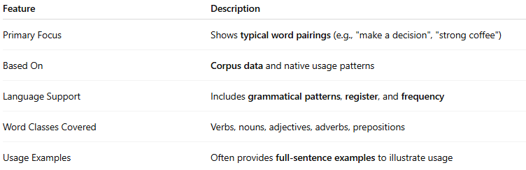
Feature | Description
Primary Focus | Shows typical word pairings (e.g., "make a decision", "strong coffee")
Based On | Corpus data and native usage patterns
Language Support | Includes grammatical patterns, register, and frequency
Word Classes Covered | Verbs, nouns, adjectives, adverbs, prepositions
Usage Examples | Often provides full-sentence examples to illustrate usage

🔹 Examples of Collocation Dictionaries
# Source: AI Source: Provided by: [Data Path: Persons Table -> ID Column: 1, Name_En Column: Motasem Essam] -> From: [Chatgpt (GPT-4-turbo)] on [7/29/2025]
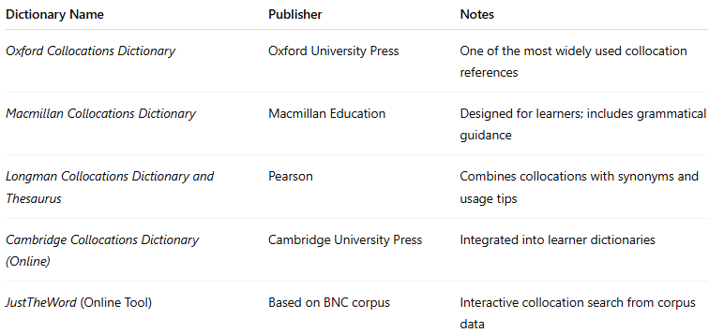
Dictionary Name | Publisher | Notes
Oxford Collocations Dictionary | Oxford University Press | One of the most widely used collocation references
Macmillan Collocations Dictionary | Macmillan Education | Designed for learners; includes grammatical guidance
Longman Collocations Dictionary and Thesaurus | Pearson | Combines collocations with synonyms and usage tips
Cambridge Collocations Dictionary (Online) | Cambridge University Press | Integrated into learner dictionaries
JustTheWord (Online Tool) | Based on BNC corpus | Interactive collocation search from corpus data

🔹 Advantages
# Source: AI Source: Provided by: [Data Path: Persons Table -> ID Column: 1, Name_En Column: Motasem Essam] -> From: [Chatgpt (GPT-4-turbo)] on [7/29/2025]
- Enhances fluency and naturalness in speech and writing
- Helps learners avoid unnatural phrasing
- Strengthens vocabulary acquisition through word partnerships
- Supports academic and professional writing

🔹 Use Cases
# Source: AI Source: Provided by: [Data Path: Persons Table -> ID Column: 1, Name_En Column: Motasem Essam] -> From: [Chatgpt (GPT-4-turbo)] on [7/29/2025]
- ESL/EFL learners and teachers
- Academic and business writing
- Translation and localization
- Language testing (e.g., IELTS, TOEFL writing/speaking)

